Assignment 5
Q 1
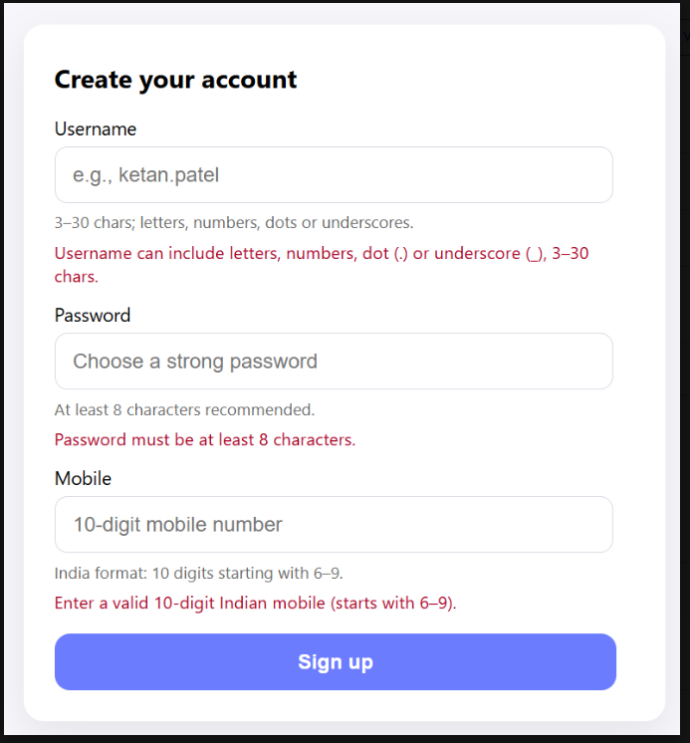

<!DOCTYPE html>
<html lang="en">
<head>
<meta charset="UTF-8">
<meta name="viewport" content="width=device-width, initial-scale=1.0">
<title>Document</title>
<link rel="stylesheet" href="bootstrap-5.3.8/dist/css/bootstrap.min.css">
</head>
<body style="background-color: beige;">
<div class="account-card max auto p-4 p-md-5 bg-white rounded-4 shadow-sm m-5">
<h1>Create Your Account</h1>
<form action="#" id="accountForm">

<div class="mb-3">
<label for="username" class="form-label">Username</label>
<input type="text" id="username" name="username" class="form-control" placeholder="e.g., Krishkumar Moradiya">
<small class="form-text text-secondary">Use letters and spaces only.</small>
<small id="usernameError" class="text-danger"></small>
</div>

<div class="mb-3">
<label for="password" class="form-label">Password</label>
<input type="password" id="password" name="password" class="form-control" placeholder="Choose a strong password">
<small class="form-text text-secondary">At least 8 characters, one capital letter, and one special character.</small>
<small id="passwordError" class="text-danger"></small>
</div>

<div class="mb-3">
<label for="mobile" class="form-label">Mobile</label>
<input type="tel" id="mobile" name="mobile" class="form-control" placeholder="10-digit mobile number" maxlength="10">
<small class="form-text text-secondary">Enter exactly 10 numbers.</small>
<small id="mobileError" class="text-danger"></small>
</div>

<button type="submit" class="btn btn-primary w-100">Sign Up</button>

</form>
</div>

<script>
const form = document.getElementById('accountForm');
const username = document.getElementById('username');
const password = document.getElementById('password');
const mobile = document.getElementById('mobile');

function showError(id, message) {
document.getElementById(id).textContent = message;
}

function validateUsername() {
const value = username.value.trim();
const isValid = /^[A-Za-z ]+$/.test(value);
showError('usernameError', isValid ? '' : 'Only letters and spaces allowed.');
return isValid;
}

function validatePassword() {
const value = password.value;
const isValid = value.length >= 8 && /[A-Z]/.test(value) && /[^A-Za-z0-9]/.test(value);
showError('passwordError', isValid ? '' : 'Must be 8+ chars, 1 capital, 1 special.');
return isValid;
}

function validateMobile() {
const isValid = /^\d{10}$/.test(mobile.value);
showError('mobileError', isValid ? '' : 'Enter exactly 10 digits.');
return isValid;
}

form.addEventListener('submit', function(e) {
if (!validateUsername() || !validatePassword() || !validateMobile()) {
e.preventDefault(); // stop form if invalid
}
});
</script>

</body>
</html>
